Spirituality and Faith Workshops and Performances
“As the granddaughter of holocaust survivors, I relied on my grandmother’s strength and spirit in order to survive, which inspired a spirituality-fueled resilience.”

See full descriptions of workshop topics at www.amyoes.com/FAITH
- Hope Builds Resilience: A Creative Approach to Faith and Survival
- Make Your Own Meaning: Creating a New Haggadah To Celebrate Our Own New Beginnings
- Post Traumatic Growth in Passover: Cultivating Resilience Through Our Story of Freedom
- Healing from Sexual Assault From a Spiritual Lens
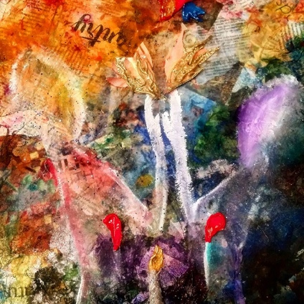
Spirituality-Inspired Art: amyoes.com/galleries
Knowing how difficult it was for me to speak of my own abuse (especially after waking up from a coma months later), I devised a program that combines Broadway theatre with sexual assault awareness and mental health advocacy, in order to empower survivors of assault and to create a more compassionate, open community. I deliver this keynote to support groups, centers, colleges and universities, to promote mental health, provide hope, help, and save lives. My program aims to identify the strength and compassion of Judaism as a transformative healing tool for trauma survivors.
My talk can also be divided into three components:
Part 1) A 70-minute one-woman autobiographical musical – Gutless & Grateful – a comedic yet poignant story on how I survived 27 stomach surgeries, organ failure, and sexual abuse. Through interwoven song and dialogue, I share a primal piece of live-storytelling – a powerful message that it’s possible for survivors become empowered by their own identity and secure in their choices.
Part 2) An educational session/speech A compassionate approach to emotional well-being, how to develop a resiliency toolbox, how to cultivate hope, foster understanding, build a supportive community, and be comfortable reaching out to a support system. Individuals will learn tools for coming forward as survivors, as well as visible allies and leaders, guided by Jewish faith, spirituality and principles.
Part 3) A Q&A session to introduce survivors to sexual assault and wellness resources available to them and answer any questions they might have.
The program can also be followed by smaller workshops to continue building confidence and compassion through creative expression.
“Amy Oestreicher did an amazing presentation to a large group of Jewish high school students at a one night a week Hebrew High School meeting at Congregation B’nai Israel in Bridgeport, CT. The course title is Hope and Survival’ and was extremely fitting to her inspiring story. Students felt comfortable enough to reach out to her after her talk, and she was a tremendous support and much-needed lift. “
-Carole Rubin, Professor at Mercaz Hebrew High School, Bridgeport, CT

Performances for Judaism and Faith

Gutless & Grateful: One Woman Musical:
One bad stomach ache after noshing on a little too much matzah at Passover Dinner changed the course of my life forever. I was your average teenage musical theatre ham, when, two weeks before my senior prom, a blood clot caused my stomach to explode, literally hitting the ceiling of the operating room. After both lungs collapsed, I almost died. When I woke from a coma, months later, doctors told me I had no stomach anymore, I couldn’t eat or drink, and they didn’t know if I’d ever be able to again. Just when you think this is going to be a why me tragedy, I share the secret thriving through 27 surgeries and 6 of the past 10 years unable to eat a morsel of food or drink a drop of liquid: humor! (All in a 70 minute musical comedy!)
Learn more at amyoes.com/GUTLESS.

Original Jewish Full Length Drama: IMPRINTS
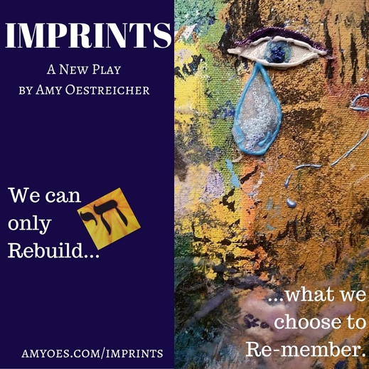
Because I fell into a coma the night my family’s Passover Seder, this holiday has always symbolized redemption and liberation as I healed through a decade of trauma. As I endured six years unable to eat or drink a drop of fluid, the phrase, “Next Year in Jerusalem” took on an entirely new meaning, while my family waited eagerly to celebrate holidays with food and health once again. This was the inspiration behind my original drama, Imprints. The script is loosely based off of a journal my brother kept for the first 72 days I was in a coma, packed with moments of raw emotion as well as endearing humor from a Jewish family who camped out in the ICU together for over a year. Learn more at www.amyoes.com/IMPRINTS

