Sexual Assault Speaking and Workshops Overview:

Amy is a speaker for RAINN (www.rainn.org and an expert for the National Sexual Violence Resource Center: https://www.nsvrc.org/profile/9900

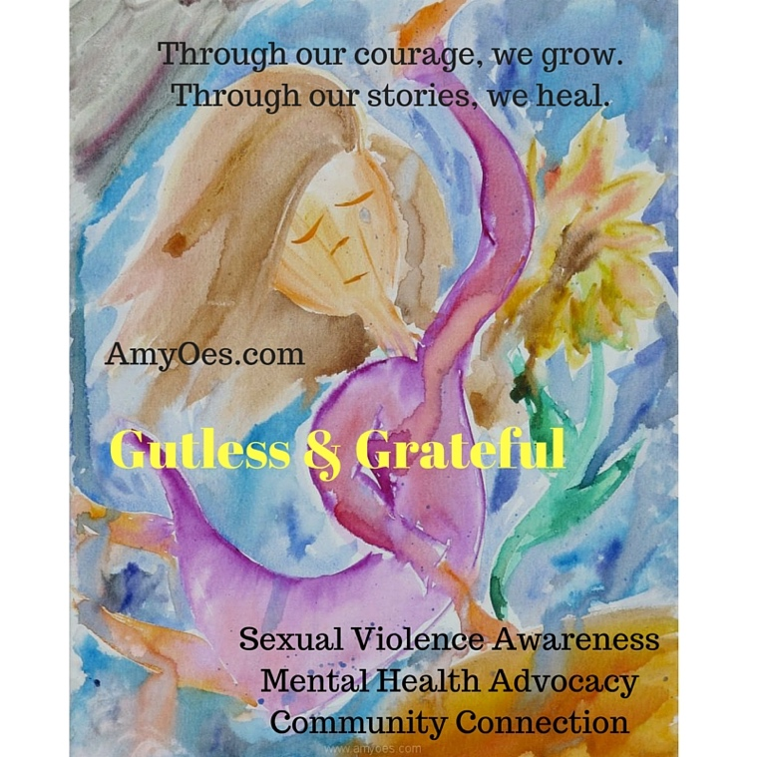
At 17, I was molested for almost a year by my voice teacher, then at 18, mystomach literally exploded due to an unforeseen blood clot, I was in a coma for months, and almost died. Now, I’m an artist, actress, author, playwright, “survivor-to-thriver”, and lover of life’s beautiful detours. I’ve been through my own ordeal of sexual abuse, 27 surgeries, organ failure, six years unable to eat or drink and, of course, the PTSD that comes from ten years of trauma. (See a full bio here.)
I fell into a coma only a week after breaking silence of my abuse, so when I awoke 6 months later, I was very…confused to say the least! It has been a long road to healing, but my “beautiful detour” has inspired me to provide college students with an empowered approach to mental health.
When I realized that many students were afraid to reach out for proper help on campus or, worse, weren’t even aware of the mental health resources available, I was inspired to develop a keynote that combines Broadway theatre with sexual assault awareness and mental health advocacy, providing hope, help, and saving lives.

The Power of Our Stories
Until I was able to tell my story, at first for myself, and ultimately, to others, I was not able to fully heal.
The day I reached out, I found connection, acceptance, forgiveness, and my self. And I love who I found.

Workshops and Speaking

- Compassionate Courage: Sexual Assault Prevention
Empowerment Through Our Stories

Combining mental health advocacy and sexual assault prevention with autobiographical theatre, a talkback on resiliency, and a recovery Q & A, Compassionate Courage shifts the college ethos towards inclusion, to give courage and a sense of belonging to students who are struggling with mental health or physical challenges, and to help build a campus that gives survivors, bystanders and entire student body an awareness and generosity of spirit to creates a compassionate community.

Part 1: Performance: Through autobiographical theatre, participants will understand how sexual assault, PTSD, and disability can affect an individual, and receive a powerful message that it’s possible for students to become empowered by their own identity and secure in their choices.

Part 2: Educational session/speech: Participants will learn coping skills, a compassionate approach to emotional well-being, how to develop a resiliency toolbox, how to cultivate hope, foster understanding, build a supportive community, and be comfortable reaching out to a support system. Individuals will learn tools for coming forward as survivors, as well as visible allies and leaders for all students.

Part 3: Q & A: Participants will learn about available sexual assault and wellness resources, dispel rape myths, understand Title IX, understand bystander prevention, and will be guided through prompts to find comfort in using their voice and become empowered by their own stories and affected by the stories of others. Individuals will learn how to start to form small networks of support and seek out available resources, creating more informed and de-stigmatized world. The program's intention is to plant the seed for the individual feeling overwhelmed by their condition, as well as to create awareness for supporters, to start viewing it as a story they can share, connect with, and find healing in the openness and honesty of connection and shared "detours" in life.

Amy Oestreicher is a PTSD peer-peer specialist, artist, author, writer for The Huffington Post, award-winning health advocate, actress and playwright. Surviving 27 surgeries, a coma, sexual abuse, organ failure and a decade of medical trauma, Amy shares lessons learned from her "beautiful detour" through her writing, acclaimed artwork, performance and speaking. Amy has written and starred in Gutless & Grateful, her one-woman musical autobiography, which she tours across the country as a mental health advocacy program.

Participants will:
Increase awareness of sexual assault on campus
Dispel rape myths
Understand bystander prevention
Cultivate Self-Love
Learn how to use their voice and share their story
Create a support system
Learn about a supportive attitude and how to help a friend
Become aware of campus resources
Develop coping skills
Build leadership skills
Begin to heal from numbness
Come forward as a strong community of support for the student body

- Sexual Assault Prevention on Campus: Community Impact and Response

How do we commit ourselves to sexual assault awareness on campus? Through striving to give courage and a sense of belonging to students who are struggling, and to help build a campus that gives survivors, bystanders and student body an awareness and generosity of spirit to create a compassionate community.

Understand how sexual assault and PTSD can affect an individual, and the importance of community awareness and informed support system.

Help individuals identify the symptoms of PTSD in relation to sexual assault, discover safe means of experiencing emotions and memories, and develop a resiliency toolbox

Identify sexual assault and wellness resources and use expression, communication and sharing their story as a means for rebuilding and moving forward.

Gain new understanding on the psychological aspects of sexual trauma, and be able to identify the "flight" "freeze" or "flee" responses

Create meaningful dialogue and engagement with survivors and help facilitate expression, communication and sharing their story as a means for rebuilding and moving forward.

Learn techniques to incorporate creative therapeutic responses which integrate the physical, mental, energetic and spiritual impacts of trauma

Recognize common symptoms of PTSD after sexual violence including intrusive memories, avoidance, hypervigilance and disassociation

Identify coping skills to help survivors deal with the debilitating effects of PTSD

how to cultivate hope, foster understanding, and build a supportive, informed community.

Identify sexual assault and wellness resources for students, dispel rape myths, understand Title IX, and learn appropriate intervention tactics

Combining sexual assault prevention with musical theatre, Amy shares how sexual abuse, and a decade of medical trauma, caused her severe PTSD. Participants will gain an appreciation of how PTSD affects survivors and how, only through learning to feel, will they be able to move through trauma and rebuild themselves.

- Bystander Prevention: Understanding the Freeze Response

Addressing the problem: For many survivors, the complex feelings of trauma, shame and powerlessness that accompany an assault can be followed by silence.

What is PTSD? Where can PTSD come from?
Where does shame come from?

Identify responses to sexual trauma: Flight, Freeze, or Fight

Identify debilitating impacts of trauma on humans – why we develop PTSD, and our response to trauma vs. a wild animal’s response to trauma: We survivors relive their abuse. How do we break the cycle?

What are the psychological effects of trauma? Symptoms of PTSD?

How does stigma, fear and shame affect a survivor?

Define terms: Hypervigilance, Disassociation, Avoidance, Intrusive Memories, Flashbacks

How can you identify these in a survivor?

What are tools, terms and processes to address these symptoms?

Part 2: Educational session/speech: Participants will learn how to address PTSD after trauma through identifying coping skills, fostering compassionate approach to emotional well-being, developing a resiliency toolbox, tools for cultivating hope and building a supportive community

Working on a community-level: Identify tools for the community to come forward as survivors, as well as visible allies and leaders

What is the power that comes from speaking out? How do we help facilitate a dialogue?

How do we help survivors heal from numbness?

Cultivating Pride in Survivors: Freeze is Self-Defense

Re-introducing the five “superhero senses” and helping individuals "feel their bodies."

How we help integrate the past to move forward: Re-membering the pieces lives, re-constructing identities

Part 3: Q & A: Participants will learn how to provide the needed support for survivors by empowering them with knowledge: dispel rape myths, understand Title IX, address bystander prevention

A plan for guiding survivors through prompts to find comfort in using their voice, and become empowered by their own stories as well as affected by the stories of others.

How do we teach survivors how form small networks of support and seek out available resources, creating more informed and de-stigmatized world?

Help survivors develop new skills related to consent, healthy relationships, and bystander intervention.

Forming our intention as facilitators: to plant the seed for the individual feeling overwhelmed by their condition, as well as to create awareness for supporters, to start viewing it as a story they can share, connect with, and find healing in the openness and honesty of connection and shared "detours" in life.

The snowball effect How we can create activism and advocacy – helping survivors find their voice and strengthen the voices of others.

